Justin Marucci

Assignment 7

04/26/2025

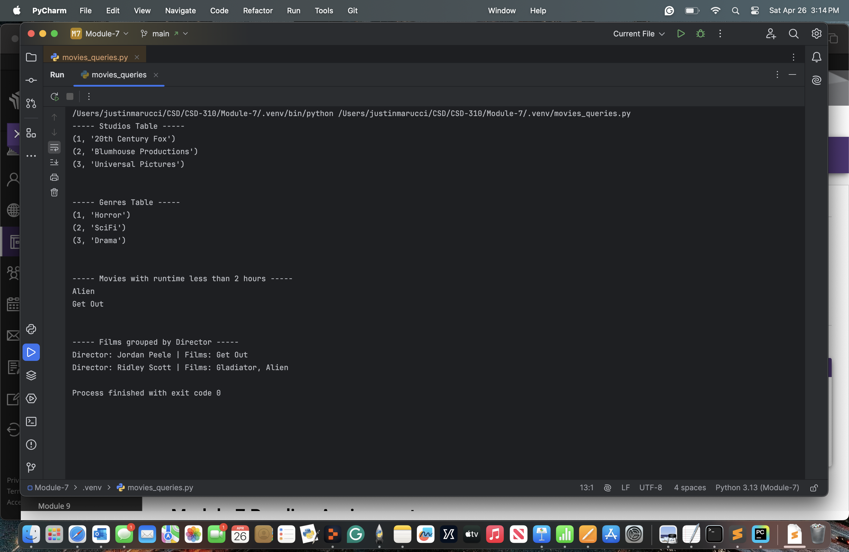

<https://github.com/Marucci212/CSD-310/tree/main/Module%207>